
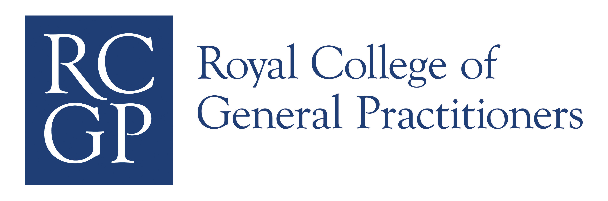

Learning needs assessment, education objectives and personal development plans for licensing in
GP specialty training.

Dr Jane Mamelok

RCGP Workplace Based Assessment Clinical Lead.
Associate Director of Postgraduate GP Education,
North Western Deanery.

October 2010

Personal Development Plans (PDPs) for workplace based assessment (WPBA in GP licensing)

Introduction

There has been a lot of work done on developing material on learning logs that can be used for modelling with GP specialty trainees (GPSTs) and benchmarking judgements with educators. However there is little done around PDPs.

Reviewing e-portfolios it is clear that the majority of trainees (particularly those in their early years in the programme and in secondary care) are poor are formulating educational objectives. Many of the PDPs reviewed provide a working task list (tick box approach) for each post. The reasons behind this are fundamental to improving standards.

In any educational intervention it is important to consider the educational triangle.
The Educational Triangle

Aims & objectives
Methods
Assessment & Evaluation

In order to set clear aims and objectives, learning needs assessment (1) needs to be undertaken. Knowing what you need to learn to develop requires professional insight and the ability to reflect, attributes we know are a “needs further development – NFD) for the majority of GPSTs.
I would therefore argue that to improve the quality of PDPs we need to work with trainees to develop reflective learning skills exploit the analytical potential
of the e-portfolio and close the insight gap between confidence and competence.

Learning needs assessment

How do you know what you need to know?
How do you know what you know?
How do you know what you don’t know?

What I am describing is Johari’s window (2), a pictorial representation describing what is known to self and others.

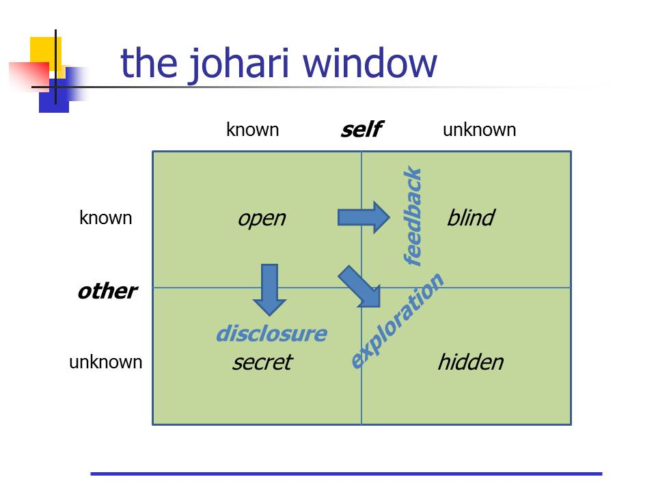

Reflection is a very powerful tool to help explore the unknowns of Johari’s window. Some of the tools for self assessment and learning needs assessment are available to trainees and they are familiar with them, MCQ, knowledge based test and quizzes, curriculum coverage review, the learning log, PUNs & DENs (3) case based discussion (with appropriate feedback) case analysis (4) and significant event analysis. One of the problems is that entries that are descriptive and lack that analytic critical appraisal (reflection) rarely result in change in deeper learning with insight and a resulting change in behaviour.

Schon (5) described reflective practice in two stages, reflection ON action and reflection IN action. Using structured reflection, alone or with colleagues helps to take a different perspective, explore the implications, define learning points to develop and set objectives and strategies to change professional behaviour.

This sort of experiential learning uses reflection develop and leads to deeper learning. (Kolb’s learning cycle)

Kolb’s Learning Cycle (6)

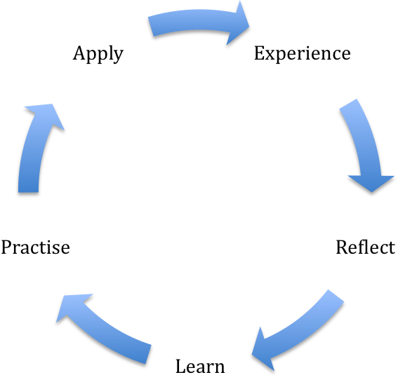

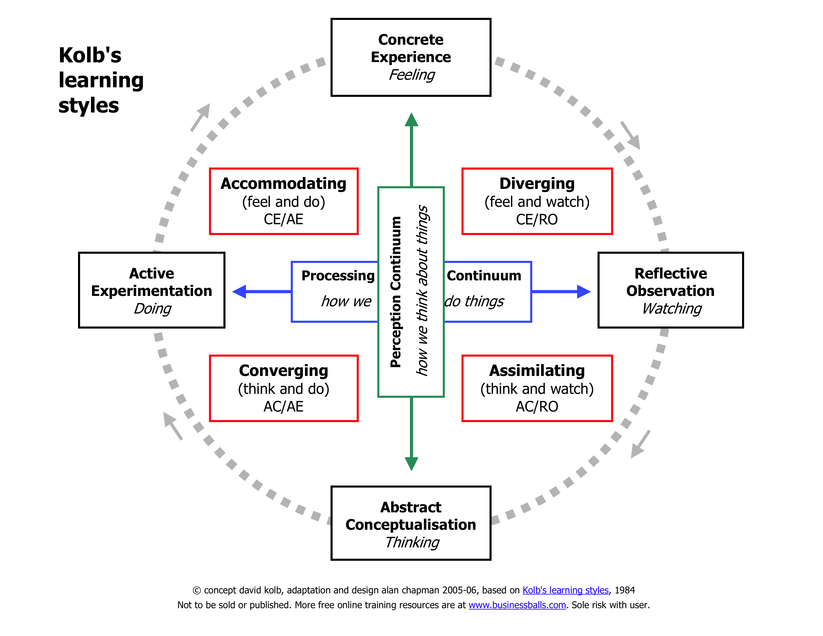

So can we teach reflection?

We have some reflective criteria that can be used to help trainees understand what we mean by reflection and improve the quality of their learning log.

Table 1: Scoring system for reflective entries (Mc Neill et al AMEE 2008)

Level 1 – Least Reflective | Level 2 - Intermediate | Level 3 - Most Reflective
Entirely descriptive / narrative in style  No evidence of analysis  No evidence of learning  Incomplete form / missing  Information  Appears rushed  Does not appear to ‘value’  reflection or see learning  opportunities | Some evidence of critical  thinking and analysis  Limited emotional  Involvement  Some description  Evidence of learning  Some self awareness  Some action planning  May or may not consider  others | Analysis and critical thinking  Considers feelings of self and others  Strong evidence of learning  Evidence of action planning for the future  Contextual information  Provided  Related learning to literature

The reflective process has changes the way we manage continuing professional development. Protected time for structured reflection (6), identifying one on two key learning points and developing those themes as objectives for the PDP helps to build a more discriminating appraisal/educational portfolio).

Aims and Objectives (taken form Dundee Certificate in Medical Education CD:4.3)

In everyday language, the terms aims and objectives are synonymous. Both mean “that at which we direct our energies” However, in an educational context, each term has a unique meaning.

An aim is an overall purpose or intention. A curriculum aim specifies the direction of travel, not the distance.

An aim:

- Is a foreseen end that gives direction to an activity
- Is relevant to the situation
- Is flexible and capable of being changed
- Encourages a freeing of activities

An objective is more precise and more detailed than an aim: it relates to one aspect of a specific aim.

An objective usually describes a desired educational outcome.

It is often expressed in terms of what the learner should be able to do at the end of the course of instruction. In that context objectives are intimately linked to assessment.

Objectives are both observational and measurable. They tell both teachers and learners about the “what”, “why” and “how” in teaching; learning and assessment. Objectives can be in the cognitive (knowledge), psychomotor (skills) and attitudinal domains.

Bloom’s Taxonomy (8)

Bloom described six levels of educational objectives, which can be helpful planning teaching and learning.

Bloom described 6 different levels of educational objectives

Cognitive | Psychomotor | Affective
Knowledge | Skills | Attitude
1. Recall data | 1. Imitation (copy) | 1. Receive (awareness
2. Understand | 2. Manipulation (follow instructions) | 2. Respond (react)
3. Apply (use) | 3. Develop Precision | 3. Value (understand and act)
4. Analyse (structure/elements) | 4. Articulation (combine, integrate related skills) | 4. Organise personal value system
5. Synthesize (create/build) | 5. Naturalization (automate, become expert) | 5. Internalize value system (adopt behaviour)
6. Evaluate (assess, judge in relational terms)

It is useful to refer to these when formulating objectives.
Are they low level – factual recall only or higher requiring application/analysis of that knowledge?

Objectives (and their level in Bloom’s) are contextual and related to the workplace and posts. Each curriculum statement outlines a number of intended learning outcomes (ILOs 9) that detail relevant educational objectives and describe some of the learning opportunities that might provide that experiential learning. Many trainees and educators do not access these evident by the poor curriculum linkage in the e-portfolio.

So to answer Bitty’s question how do we improve PDPs and how many items should there be in each PDP? It’s complicated.

- PDP objectives should be specific and detailed, perhaps the educational supervisor can facilitate expansion considering Bloom’s so set at an appropriate level for the context and stage of training.

- How many entries ? Sufficient to demonstrate completion of Kolb’s learning cycle with evidence of that learning detailed in the e-portfolio using the assessment tools and learning log. Aim for quality rather than quantity.

Below is an illustrative example of the sort of high quality PDP objectives.

PDP Aim | Linked objectives | Actions
1. Develop communication skills. | - Communicate with sensitivity & empathy, explaining the diagnosis and investigation and management pathway.  - Communicate in patient centred manner.  - Breaking bad news effectively.  - To communicate with colleagues and understand principles of teamwork working with allied health professionals.  - Make an appropriate and succinct written referral with relevant medical information, to allow appropriate triage in secondary care. | Video consultations, use COT for analysis and feedback.  COT/CBD  COT  Reflective learning log entries with examples of breaking bad news, where malignancy or poor prognosis suspected.  Examples in learning log e.g. effective handover team meetings.  Referral review with trainer; effective referral as validated learning log entry.

As a teaching exercise in trainers groups or with trainees it might be helpful to break the objectives down into Bloom’s and then identify learning opportunities to provide that experience; mapped to curriculum objectives.

A lot of this work has already been done (East of England Deanery) and there is no need to reinvent the wheel, this can certainly be helpful when working with secondary care and clinical supervisors.

References

- Grant, Janet (2002) Learning in practice: learning needs assessment, assessing the need. BMJ 2002 324: 156 – 159

- http://kevan.org/johari accessed October 2010

- Richard Eve (2003) PUNS and DENs Discovering learning need in general practice – Radcliffe Medical Press, Oxford.

- Pringle M 1995 RCGP Occasional Paper 70 Significant Event Auditing RCGP London 1995.

- Schon DA (1983) The Reflective Practitioner: How Professionals Think in Action New York (NY) Basic Books Inc.

- Kolb D (1974) Experiential Learning. Prentice Hall, London in Middleton & Field (2001). The GP Trainers Handbook Radcliffe Medical Press, Oxford.

- Leicester Structured Reflective Template 2007 http://www.appraisalsupport.nhs.uk/news4.asp?item=08052007090123 accessed August 2008

- Bloom, B. S. et al 1956 Taxonomy of Educational Objectives: Handbook 1 Cognitive Domain. New York D McKay. http://www.businessballs.com/bloomstaxonomyoflearningdomains.htm#bloom%27s%20taxonomy%20overview

- RCGP Curriculum Statement 1: Being a General Practitioner http://www.rcgp-curriculum.org.uk/curriculum_documents/gp_curriculum_statements.aspx Accessed 6/6/09

Jane Mamelok
RCGP WPBA Clinical Lead
Associate Director GP Education, North Western Deanery
Email w: j.mamelok@nwpgmd.nhs.uk
Email h: dhobbs@btinternet.com
Mobile: 0774 7795 706

