
.
International Medical Graduate Toolkit
 | Notes for Trainers and Educators | 9

 | How can trainers help IMGs succeed in training?
 | IMG Induction for GP Posts

Author:
.   | John Marlow

How can trainers help IMGs succeed in training?
International Medical Graduates are often the most interesting and rewarding trainees to have in practice. They are motivated, appreciate and engage with help that is offered and bring a rich life experience to the practice team.

They can, however, feel isolated and turn to their trainer for support, who in turn may feel unsure about the best educational strategies to use and how to access these.

There is lots of research about the difficulties International Medical Graduates face, which are summarized in the “Secrets for Success” section of the toolkit. There is little research, however, about interventions that make a difference. IMGs are of course individually very diverse and have different learning needs so there will not be a one-size-fits-all approach. As trainers, we spend the most time with our IMGs and have the greatest influence on their training. So how can we help them succeed?

Two things we do know are crucial are early intervention and a positive trainer-trainee relationship. It is time well spent to really get to know your IMGs, understand their backstory and build a relationship of openness and trust.

My intention with the toolkit is that it will also be useful for trainers and educators. Some sections could form the basis of a practice tutorial or aspects of consulting highlighted in a video could be used as the focus of feedback when observing a trainee’s consultation.

In Coventry and Warwickshire, we are running a series of 7 half day communication skills workshops for IMG GP trainees during their ST1 and ST2 GP posts which are themed on topics in the toolkit. We are happy to share how we run these if other VTS areas are interested in running similar programs.

There is lots of good work to help address differential attainment happening across the country. Including this here is beyond the scope of the toolkit which I want to be a practical resource but I’ve listed links to some of this work including resources for trainers from the excellent Bradford VTS website, the London Differential Attainment Toolkit and the North West England Consultation Toolkit on FourteenFish which is currently funded for West Midlands trainers.

International Medical Graduates - Bradford VTS
Differential Attainment Toolkit | London (hee.nhs.uk)
North West England Consultation Toolkit - FourteenFish

The final video suggests ways in which you can tailor your practice induction for IMGs based on educational theory and the findings from 2 large surveys of GP trainees and trainers by the Midlands Differential Attainment working group.

I hope you find the toolkit useful and welcome feedback and suggestions for improvement.

John Marlow
John.marlow@hee.nhs.uk

IMG Induction for GP Posts: Video clip
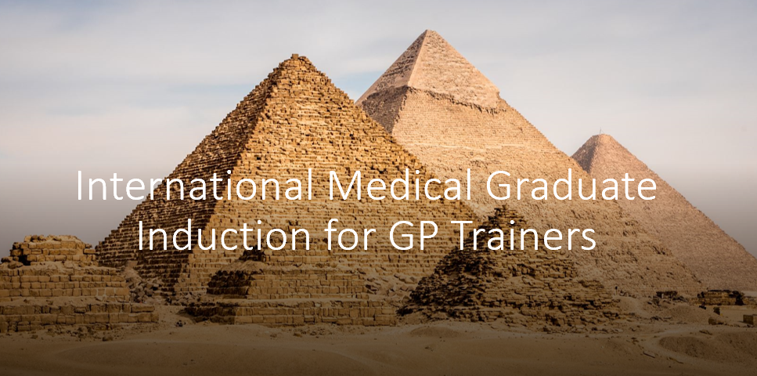 |   By Dr John Marlow  Video summary

