
.
International Medical Graduate Toolkit
 | Explanations | 8

Estimated completion time: 20 minutes
This tutorial will help you to structure your explanations:
 | Explanations
 | Clear Clinical Explanations
 | Narrative Explanations

Tutorial Author:
.   | John Marlow

Explanations
So we’ve listened to the patient’s story, possibly done an examination, and formulated our working diagnosis and provisional management plan. How can we communicate this effectively to our patients?

This doctor “talk heavy” part of the consultation often goes wrong because we speak too much, lose the patient and often confuse ourselves!

The first video clip demonstrates how to give clear clinical explanations by using the information you have gathered in the first half of the consultation.

The second video continues the narrative theme, discussing how you can structure a more complex explanation to make it understandable and relatable to your patients.

Ask your trainers and other doctors at the practice how they explain common diagnoses and steal their best ideas!

Clear Clinical Explanations: Video clip
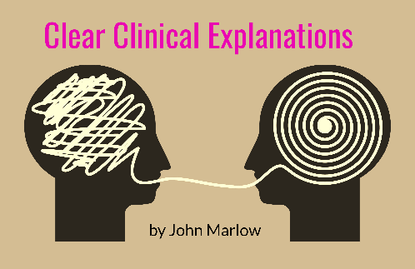 |   By John Marlow

Narrative Explanations: Video clip
 | By John Marlow

