
.
International Medical Graduate Toolkit
 | Narrative Consulting | 7

Estimated completion time: 20 minutes
This tutorial will show you how to approach the GP consultation:
 | Narrative Medicine

Tutorial Author:
.   | John Marlow

Narrative Medicine
Paradoxically, this is the section that I will give the least narrative.

There is a fundamental difference between listening to the patient’s problem and listening to the patient’s story. The latter is what leads to an effective GP consultation and what you need to demonstrate in RCA or CSA.

All I suggest you do for this tutorial is to watch the video and when you are consulting in your practices make a real effort to “focus on the story”.

Narrative Consulting: Video clip
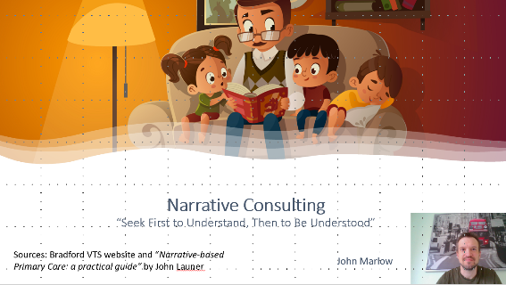 |   By Dr John Marlow

