
.
International Medical Graduate Toolkit
 | Consulting with cultural awareness | 7

Estimated completion time: 30 minutes + online resources
This tutorial will help you understand how to succeed in GP training:
 | Culture and Health
.  | Cultural Competence During the consultation

Tutorial Authors:
 | Dr Mustafa Ibrahim
 | Dr Peter Gregory
Relevant for IMG trainees and their educators

Culture and health
"The influence of culture on health is vast. It affects perceptions of health, illness and death, beliefs about causes of disease, approaches to health promotion, how illness and pain are experienced and expressed, where patients seek help, and the types of treatment patients prefer." https://kidsnewtocanada.ca/culture/influence

Both health professionals and patients are influenced by their respective cultures.

Culture can be broadly divided into 2 main categories:
Individualistic culture:
This is characterized by emphasis on individual achievements and choices, valuing autonomy.

Collectivistic culture:
This promotes relatedness, interdependence, and the focus on ‘’we’’. The concept of family is paramount in collectivistic cultures and there is a greater and broader influence of group values and views.

The UK is multicultural. Generally, British culture leans more towards individualistic culture. However, many people have a background of collectivistic culture. Being aware of the patient background can help understand many of their health attitude and preferences.

Cultural competence in a consultation
Cultural competence means being aware of and negotiating the differences in health-related perceptions and preferences that result from cultural biases.

How to master your cultural competence
- Know the distinction between principles and values
- Remain genuinely curious about other cultures (this will make multicultural consultations run easier)
- Reflect on cultural incidences, don’t giggle on them
- Accept that some difficulties might be unsolvable

Tips on how to show your cultural competence during consultation

1- Listen curiously
2- Ask, do not assume
3- Don’t get freaked out, even if you are freaked out
4- Beware of the cultural overlay on language and the linguistic overlay on culture.
5- Where relevant, arrange for an interpreter.
6- Try to ‘’locate’’ the patient in the process of adapting to local culture

Resources
- GP online article:
https://www.gponline.com/consultations-skills-multicultural-consultations/article/1067575

- Mead N, Roland M. Understanding why some ethnic minority patients evaluate medical care more negatively than white patients: a cross sectional analysis of a routine patient survey in English general practices. BMJ. 2009 Sep 16;339:b3450. doi: 10.1136/bmj.b3450. PMID: 19762416; PMCID: PMC2746268.

- BMJ article: https://www.bmj.com/content/347/bmj.f6454

Consulting with cultural awareness: Video clip
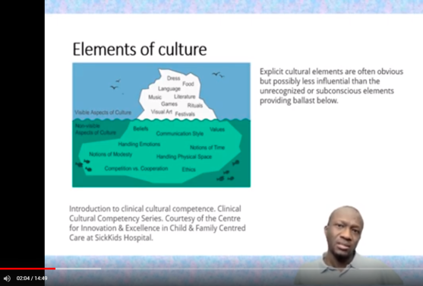 |   By Dr Mustafa Ibrahim

