
.
International Medical Graduate Toolkit
 | Consultation Models and The Hourglass Approach | 5

Estimated completion time: 20 minutes + reading and a lifetime of practice!
This tutorial will help you understand how to succeed in GP training:
 | Consultation Models
 | The Hourglass Approach
 | Recommended Books

Tutorial Author:
.   | John Marlow

Consultation Models
The GP consultation is unique.
It was invented in the UK, most research about the GP consultation has been done in the UK and no-one else does it quite like the UK does.
This is important because it explains why there is such an emphasis on consultation skills in UK GP exit exams. Following this thread, you need to devote significant time and practice to mastering this art, not just to pass exams but to have a fulfilling career consulting with patients.

Gastroenterologists master endoscopy, cardiologists master angiography, surgeons operating skills. The consultation is our tool. It’s what we do. It’s a complex skill and isn’t just talking to patients. Yet many trainees think they can blag it. You can’t!
There are lots of different consultation models and it can seem overwhelming trying to remember and understand different ones. I’m not going to go into these here because I want to keep it simple. I do encourage you to study the consultation in depth and to read the recommended books. The first 3 are shorter and easier to read. The 4th has more detail and research but also contains lots of practical suggestions.

Different consultation models suit different doctors, and you need to adapt be flexible in the consultation. The Hourglass Approach described in the following video has a straightforward patient-centred structure which I think is a nice fit for the RCA exam.

The Hourglass Approach: Video clip
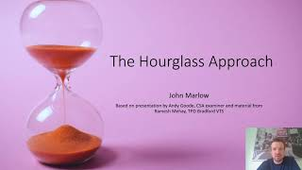 |   By John Marlow

Recommended Books
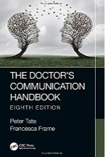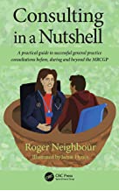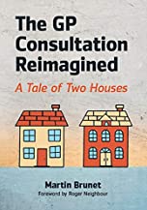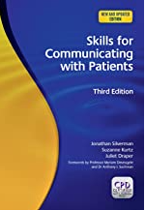

- The Doctor’s Communication Handbook
by Peter Tate and Francesca Frame
- Consulting in a Nutshell: A practical guide to successful general practice consultations before, during and beyond the MRCGP
by Roger Neighbour
- The GP consultation reimagined: a Tale of Two Houses
by Martin Brunet
- Skills for Communicating with Patients
By Jonathan Silverman, Suzanne Kurtz, et al.

