
.
International Medical Graduate Toolkit
 | Secrets for Success | 2

Estimated completion time: 30 minutes + online resources
This tutorial will help you understand how to succeed in GP training:
 | Secrets for Success
 | Success Stories
 | Celebrations and Challenges of being an International Graduate
.  | RCGP Midland Faculty Video Resources

Tutorial Author:
.   | John Marlow

Secrets for success
We know that the pass rate for International Medical Graduates in MRCGP examinations is nowhere near where it should be. In 2017-19 in the West Midlands, the first-time pass rate in the Clinical Skills Assessment (CSA) was 87% for a UK graduate and just 36.8% for a non-UK graduate. We want to change that. But how can we best achieve this? What are the secrets for success?

The following videos look at factors associated with high first-time pass rates, drawing on research and first-hand experiences from successful IMGs. Integrating these habits early in your training will lead you towards success.

Secrets for Success: Video clip
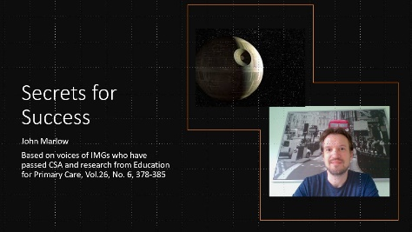 |   By Dr John Marlow

Success Stories: Video clip
 | Deepa Muthumanickam

Celebrations and Challenges of being an International Graduate
There is much to celebrate being an IMG and you bring so much to both the GP training scheme and GP practices. At our IMG workshops in Coventry and Warwickshire, we use an open forum to discuss the celebrations and challenges of being an IMG in the UK. We invite successful IMGs to come back and share what helped them. The difference I have seen in IMGs who sail through training is that they embrace challenges proactively instead of seeing them as obstacles or the fault of a failed system.

The IMGs I have worked with have brought with them a rich culture and diversity, different viewpoints and insights as well as a fun and good humour. They have made practice life more interesting and I’ve found they value the life experience of working in general practice where generalists flourish in a specialist world.

There are undoubtedly challenges. IMGs have described those listed below which can be divided in the following categories. Ways to overcome these are discussed in the Secrets for Success video and in the rest of the toolkit.
Challenges
 | Language  - Accent (both ways)  - Fluency  - Slang language  - Jokes and humour  - Intonation  - Acronyms  - Following others’ conversations  - Non-verbal communication
 | Culture  - Having to think carefully not to offend someone.  - Tendency to be overpolite.
 | The NHS  - Complaints system.  - Different resources and health care system.  - Ethical dilemmas e.g. confidentiality.
 | The GP Consultation  - Patient expectations are very different.  - IMGs often come from a more doctor-centred system.
 | On the VTS  - UK graduates often already know each other and form groups with themselves, making it difficult to form study groups with UK graduates.
 | Outside work  - IMGs often a few years older than UK GP trainees  - Other life pressures e.g. children
We are all here to learn and at my practice we learn as much from IMGs as they do from us. Immerse yourself in practice life, speak to the staff every day, do early joint surgeries with your trainer and enjoy it!

RCGP Midland Faculty Video Resources
The RCGP Midland Faculty and AiT committee put together a series of 6 webinars titled “Six steps to success in MRCGP”. Each webinar is about an hour long but time well spent to help you succeed and make the most of your GP training.
Step 1: AKT 1
Step 2: AKT 2
Step 3: RCA 1
Step 4: RCA 2
Step 5: Getting the most out of your GP training
Step 6: The psychology of success: mindset, milestones and planning

Why not join the RCGP Midlands Faculty yourself?
A great way to meet colleagues and integrate into UK General Practice. Even better, become an AiT (Associate in Training) representative and have a voice in shaping your training. The Faculty values and diversity and different insights.

RCGP Midland Faculty: Video clip
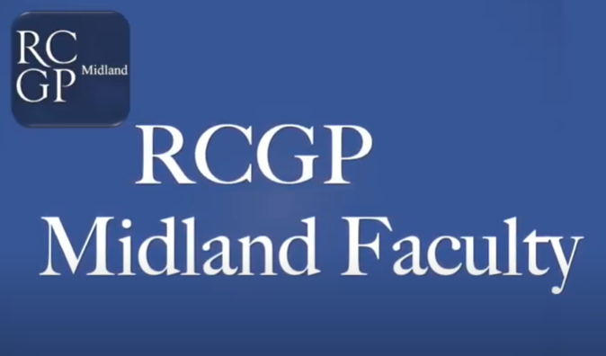 | By Dr Jamie Hynes

